Question 1: Product Order Calculator
Part 1: Display Available Products. (Marks 2)
1. Create the given JavaScript product array with id, name, category, price, and stock.
2. Create a function that displays only products whose stock is greater than 0.
3. Use a loop and an if condition.
4. Attach screenshots of the product data and the function code.

Product Data Code:
I have the product array containing id, name, category, price and stock.

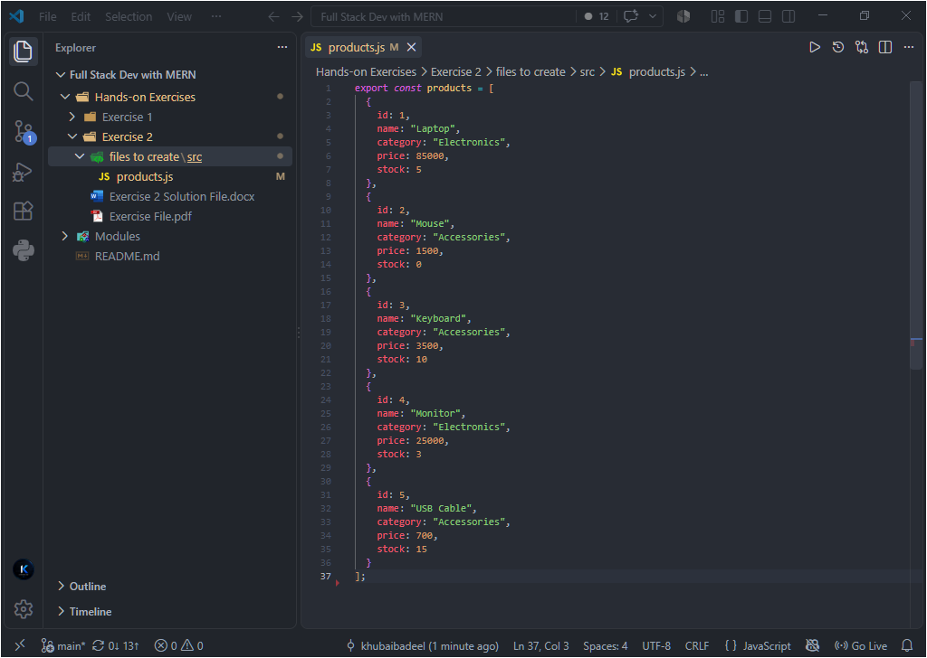

Available Products Function:
I have used a loop and condition to display only products with stock greater than 0.

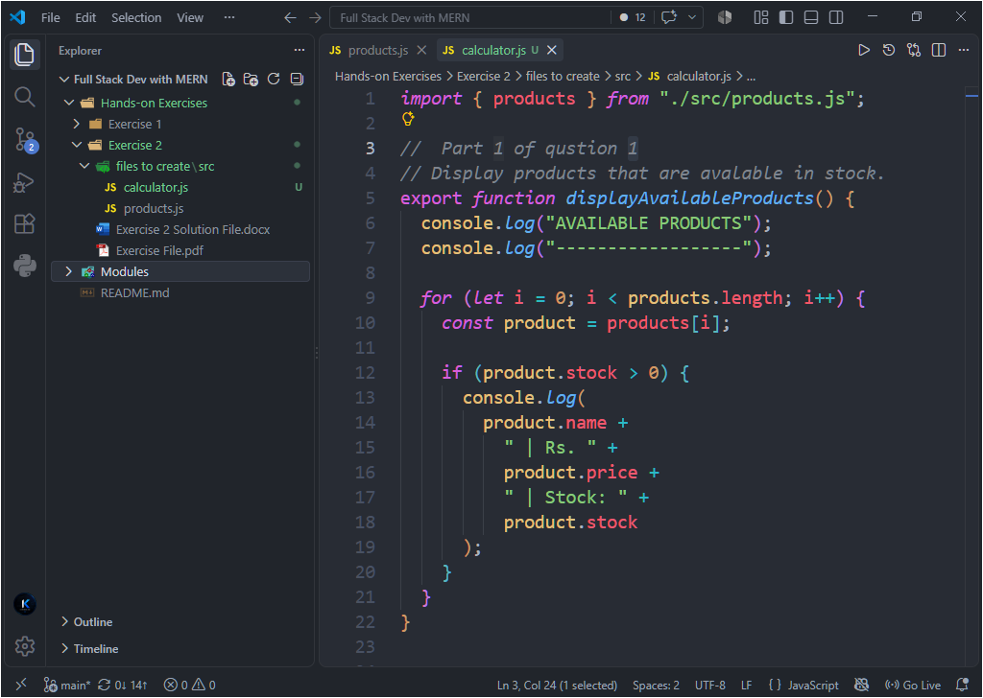

Part 2: Calculate Order Totals. (Marks 2)
1. Create sample cart items containing product id and quantity.
2. Calculate subtotal by multiplying each product price by its quantity.
3. Apply a 10% discount when subtotal is greater than Rs. 50,000.
4. Calculate the final total after discount.
Order Calculation Code:
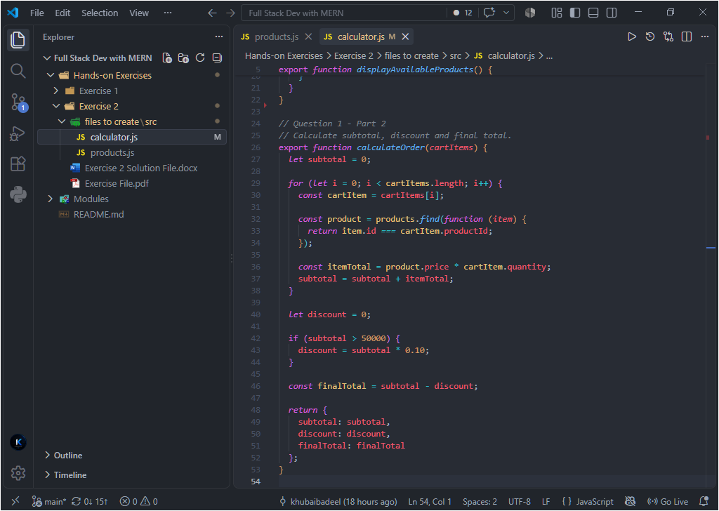

Part 3: Display the Product Order Invoice. (Marks 1)
1. Display each selected product with quantity, unit price, and item total.
2. Display subtotal, discount, and final total clearly in the console.
3. Attach screenshots of sample cart code, invoice code, and program output.
Sample Cart Code:
“I created sample cart items and passed them to my functions.”
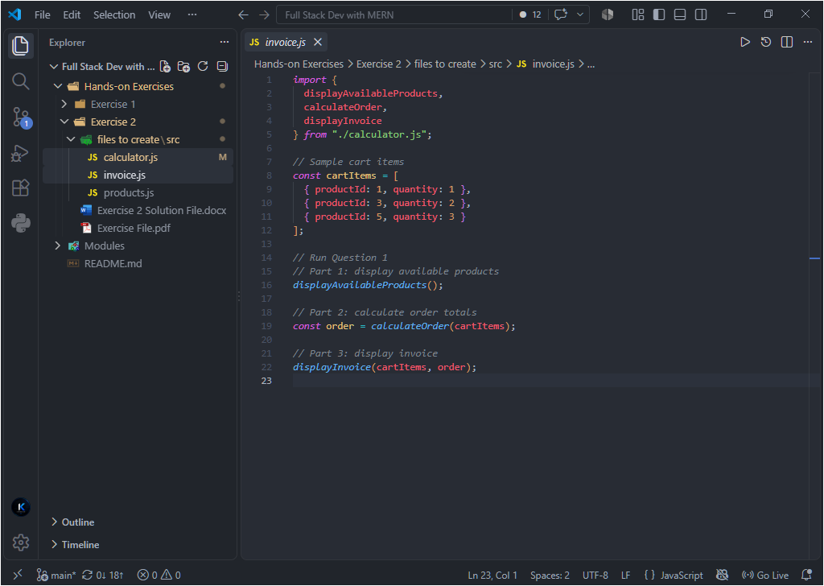
Invoice Function:
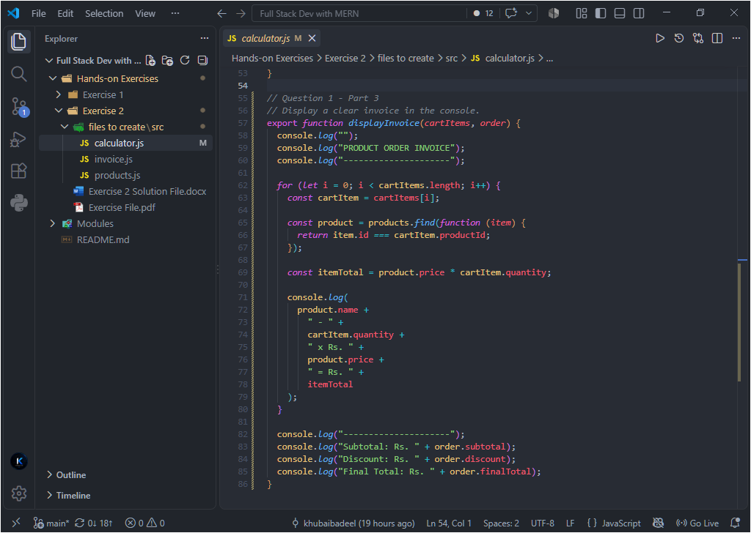

Program Output:
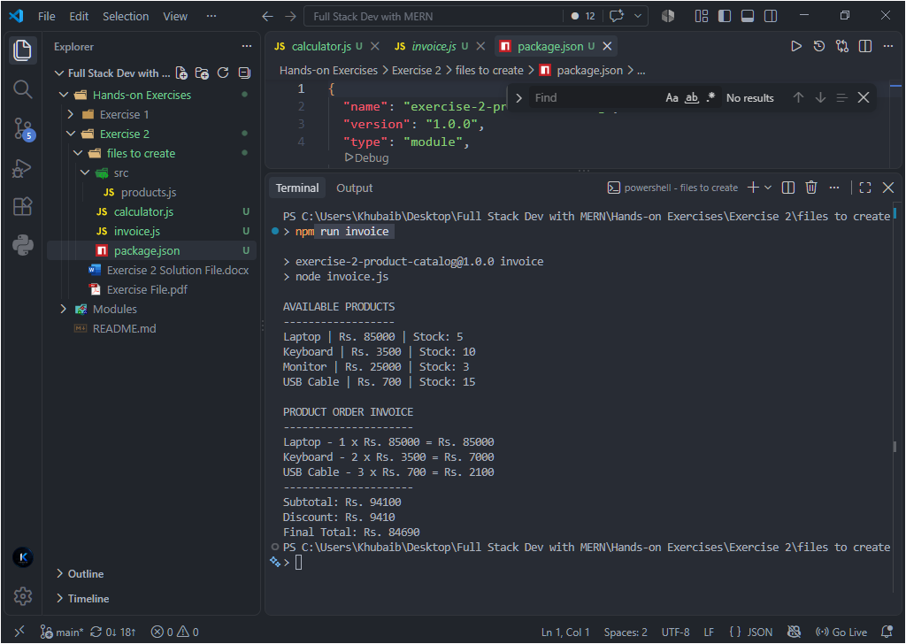

Question 2: React Product Catalog
Part 1: Create the React Project and ProductCard Component. (Marks 2)
1. Create a ReactJS project using Vite and configure the React entry point.
2. Create a reusable ProductCard component using props.
3. Display product name, category, price, and stock status.
4. Add an Add to Cart button and disable it when stock is 0.
5. Attach screenshots of the project setup and ProductCard code.
Vite Project Setup:
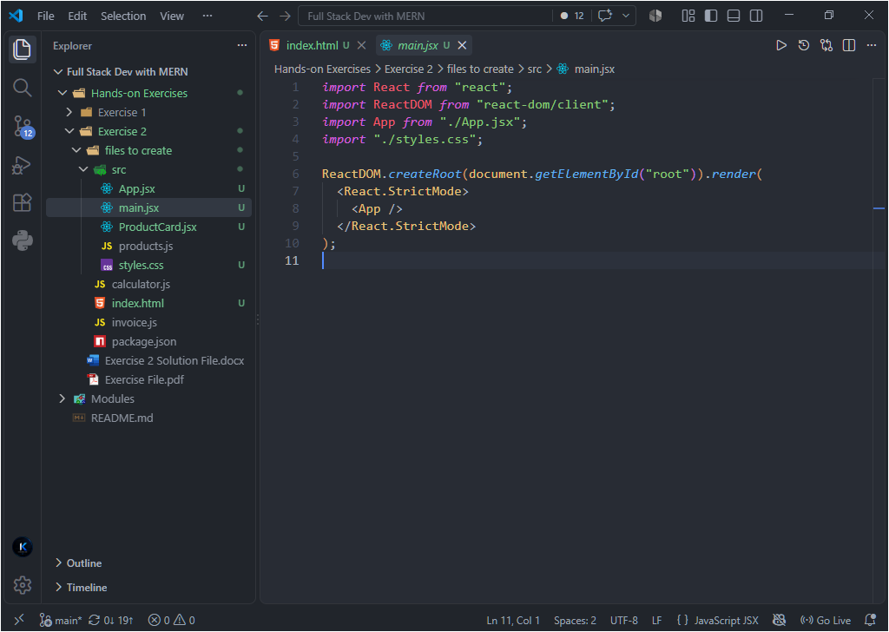

ProductCard Component:
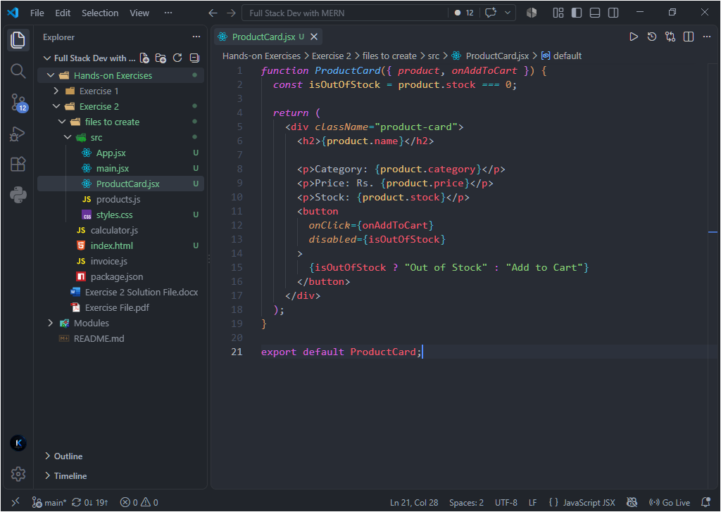

Part 2: Render the Product Array and Apply Responsive Styling. (Marks 2)
1. Store at least four products in an array and render them as ProductCard components.
2. Use the map() function to create the product cards.
3. Use CSS Grid for the catalog layout.
4. Make the catalog responsive for desktop, tablet, and mobile screen sizes.
5. Attach screenshots of the React code, CSS code, responsive CSS, and browser output.
React Code using map():
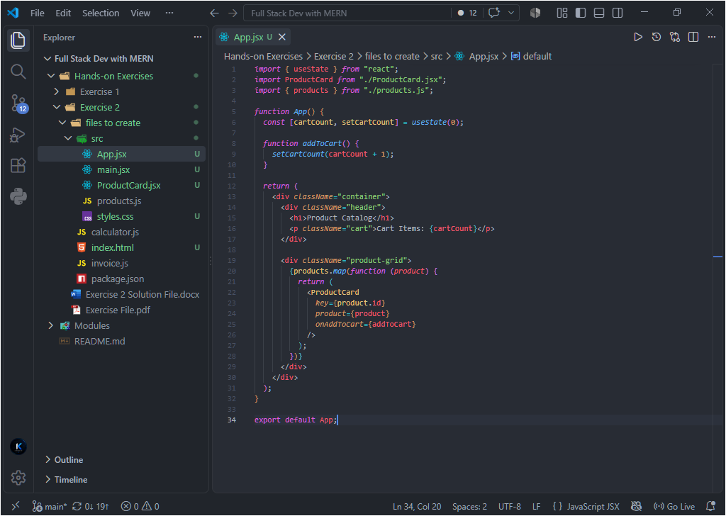

CSS Code:
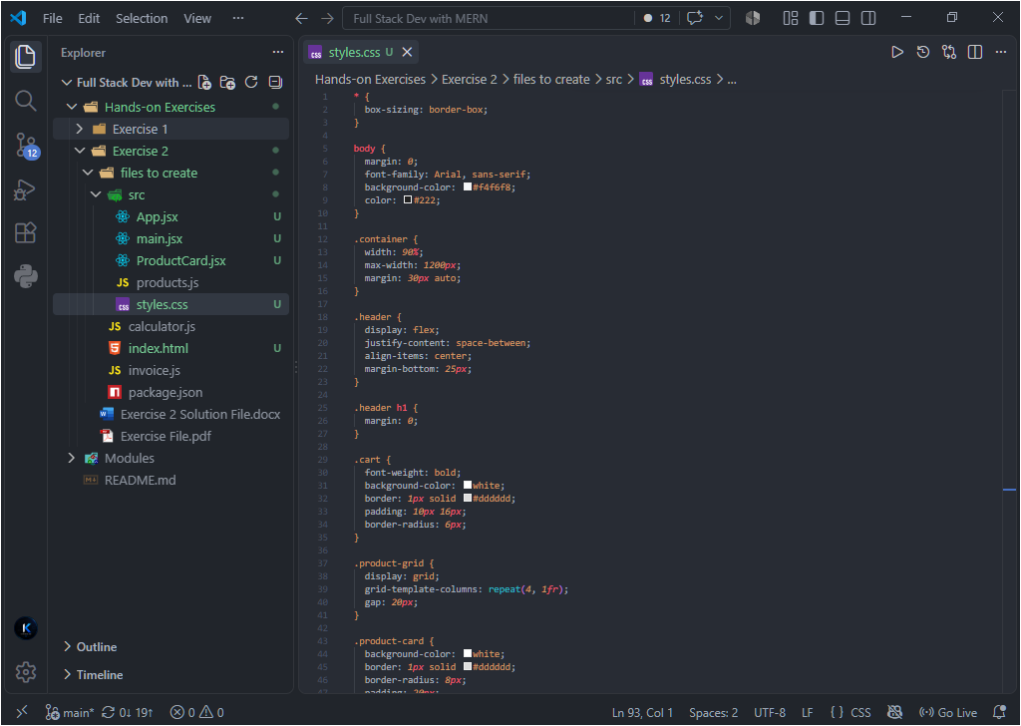
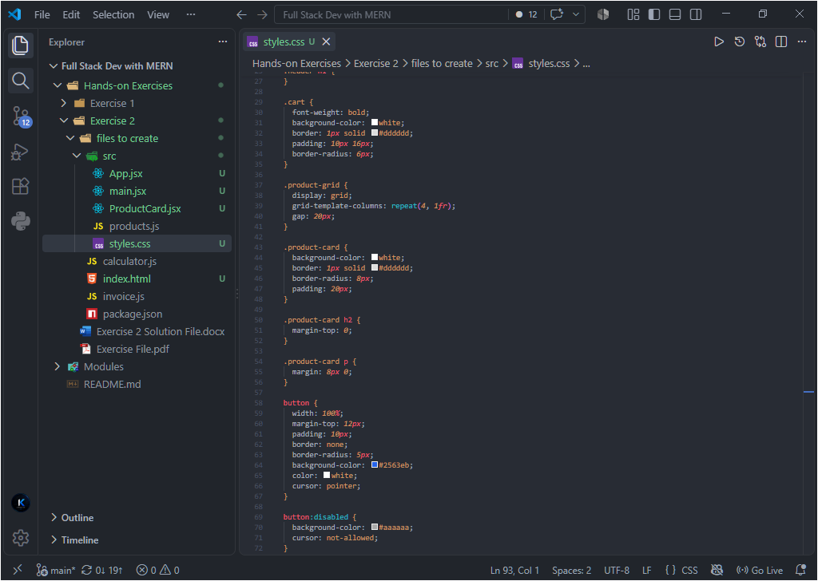
Responsive CSS:
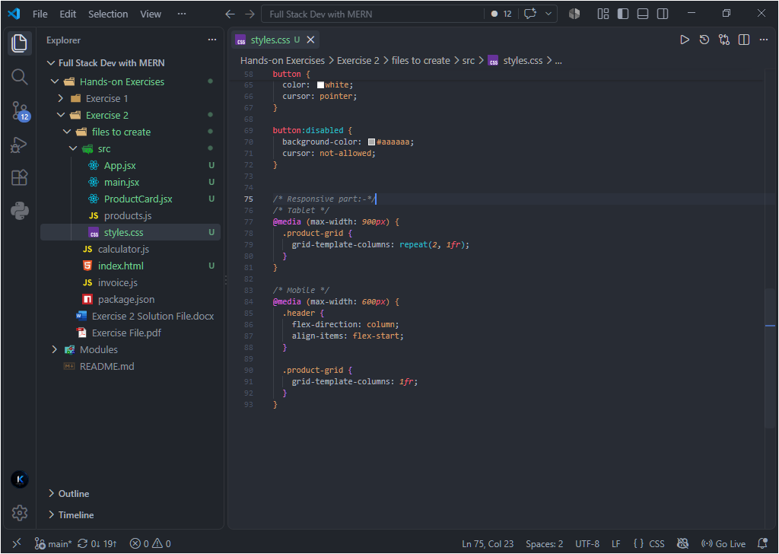

Browser Output:
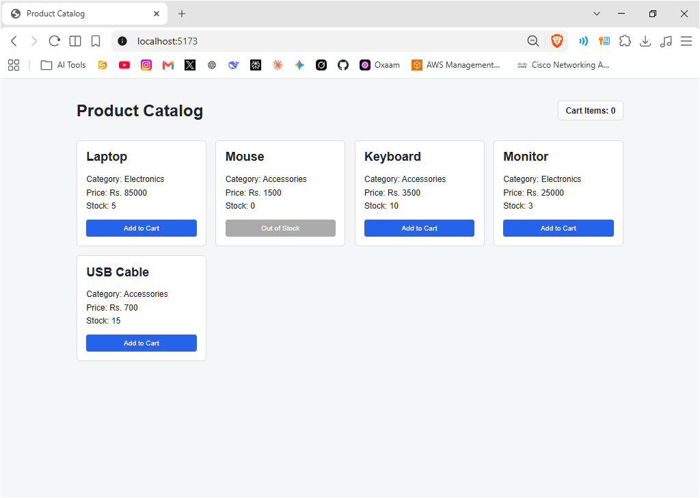

Part 3: Track Cart Items using React State and Events. (Marks 1)
1. Use useState() to store the total number of items added to the cart.
2. Create an Add to Cart click event that increases the cart count by 1.
3. Display the current cart count on the page.
4. Keep the Add to Cart button disabled for out-of-stock products.
5. Attach screenshots of the state/event code and the updated browser output.
React State and Event Handling:
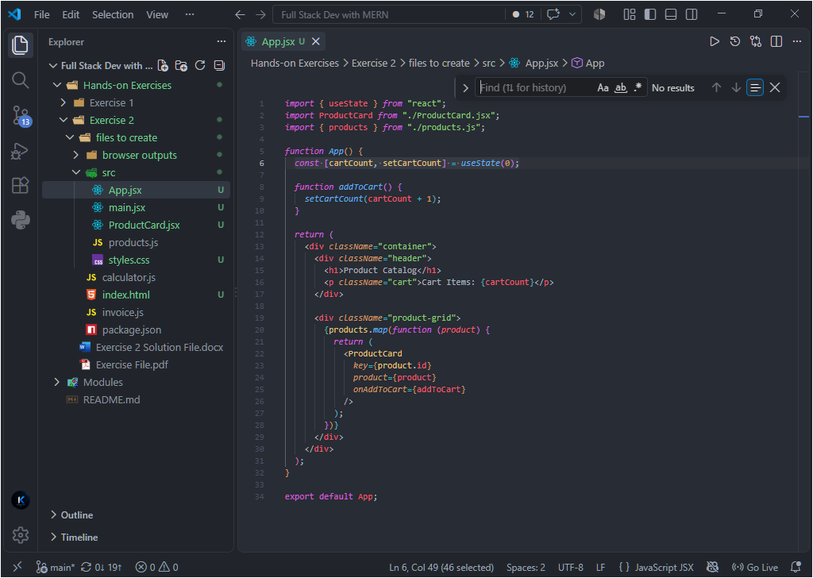

Updated Browser Output:
